1. Draw a state diagram for nondeterministic finite automata that accepts the following languages

**

**

1. Give the regular expression for the language accepted by the following finite automaton:

(a\*b)U(ba\*)

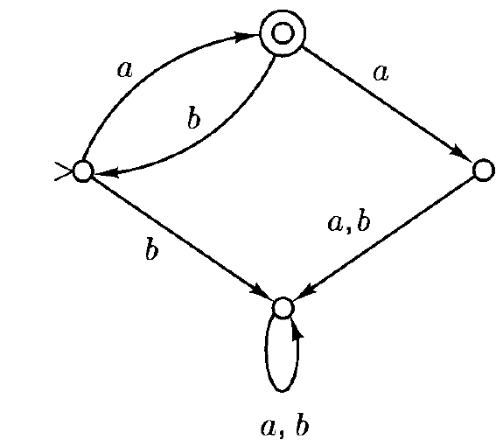

aU(ab)\*

1. Write the regular expression for the following sets
   1. All strings over $\{a,b\}$ that are odd in length

(aub)((aub)(aub))\*

* 1. All strings over $\left\{a,b\right\}$ that end with $bb$

(aub)\*bb